

Sem 2 Examination 2015

Question/answer booklet

MATHEMATICS
Please place your student identification label in this box
SPECIALIST

Section One:
Calculator-Free
Name:

Teacher:

Time allowed for this section
Section One
Reading time before commencing work: 5 minutes
Working time for paper: 50 minutes

Material required/recommended for this paper

To be provided by the supervisor
This question/answer Booklet
Formula sheet

To be provided by the candidate
- Standard items: pens, pencils, pencil sharpener, eraser, correction fluid/tape, ruler, highlighter

- Special items: drawing instruments, templates, notes on two unfolded sheets of A4 paper, and up to three calculators satisfying the conditions set by the Curriculum Council for this course.

Important note to candidates
No other items may be taken into the examination room. It is your responsibility to ensure that you do not have any unauthorised notes or other items of a non-personal nature in the examination room. If you have any unauthorised material with you, hand it to the supervisor before reading any further.

To be provided by the supervisor
Question/answer booklet for Section One, containing a removable formula sheet which may also be used for Section Two.

Structure of this paper

 | Number of questions available | Number of questions to be attempted | Working time (minutes) | Marks available | Percentage of exam
Section One  Calculator—free | 6 | 6 | 50 | 50 | 35
Section Two  Calculator—assumed | 12 | 12 | 100 | 100 | 65
 |  |  |  |  | 100

Instructions to candidates

- The rules for the conduct of Western Australian external examinations are detailed in the
Year 12 Information Handbook 2015. Sitting this examination implies that you agree to abide by these rules.

- Answer the questions according to the following instructions.

Show all your working clearly. Your working should be in sufficient detail to allow your
answers to be checked readily and for marks to be awarded for reasoning. Incorrect answers given without supporting reasoning cannot be allocated any marks. For any question or part question worth more than two marks, valid working or justification is required to receive full marks. If you repeat an answer to any question, ensure that you cancel the answer you do not wish to have marked.

It is recommended that you do not use pencil, except in diagrams.

- You must be careful to confine your responses to the specific questions asked and to follow any instructions that are specific to a particular question.

- Spare pages are included at the end of this booklet. They can be used for planning your responses and/or as additional space if required to continue an answer.
- Planning: If you use the spare pages for planning, indicate this clearly at the top of the page.
- Continuing an answer: If you need to use the space to continue an answer, indicate in the original answer space where the answer is continued, i.e. give the page number. Fill in the number of the question that you are continuing to answer at the top of the page.

- The Formula Sheet is not handed in with your Question/Answer Booklet.

Section Two: Calculator–assumed 65% (100 marks)

This section has twelve (12) questions. Attempt all questions. Write your answers in the spaces
provided.

Spare pages are included at the end of this booklet. They can be used for planning your responses
and/or as additional space if required to continue an answer.

- Planning: If you use the spare pages for planning, indicate this clearly at the top of the page.
- Continuing an answer: If you need to use the space to continue an answer, indicate in the original answer space where the answer is continued, i.e. give the page number. Fill in the number of the question(s) that you are continuing to answer at the top of the page.

Working time: 100 minutes

Question 7 (6 marks)

The diagram below shows secants AB and CD intersecting at P, dividing the circumference of the circle into arcs of lengths that are multiples of a constant a as shown. Point O is the centre of the circle.
Determine the size of the angles x, y and z, clearly showing your method.

(6 marks)
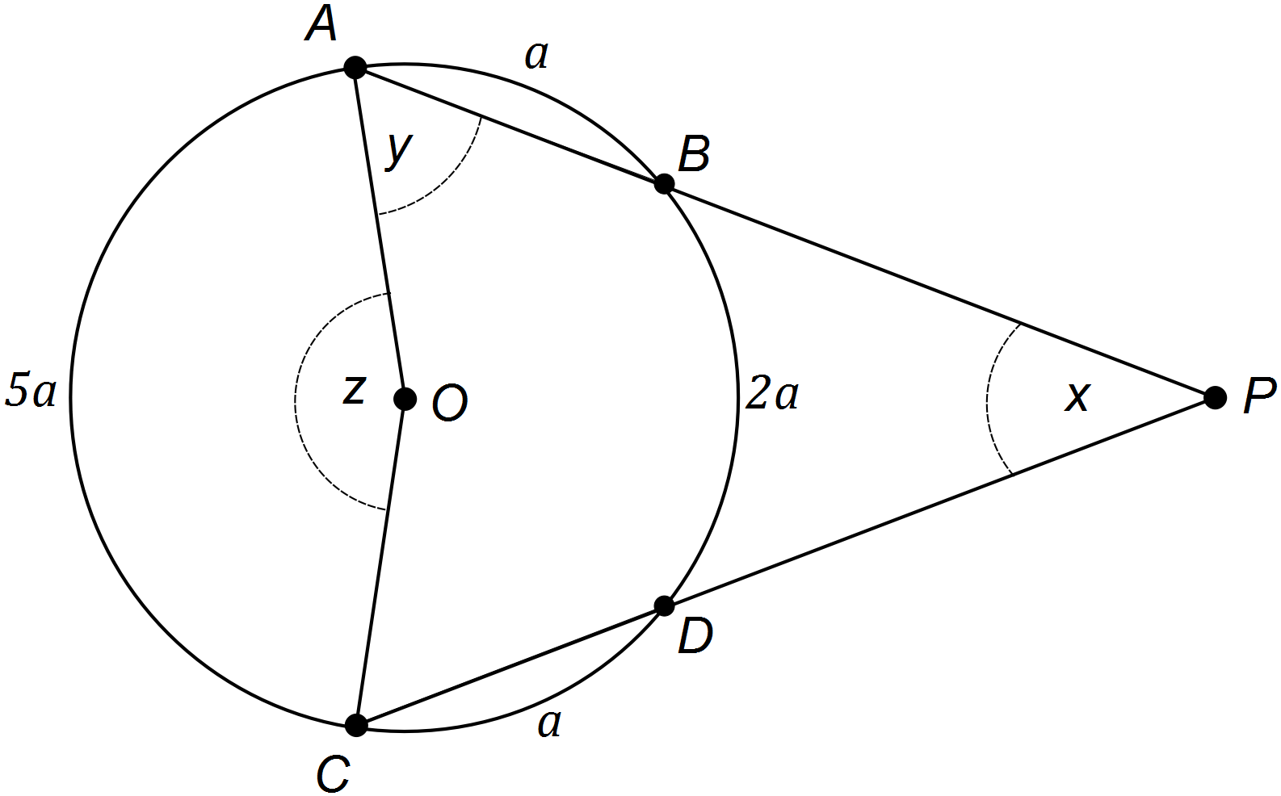

Question 8 (7 marks)

The vertices of a quadrilateral ABCD have the position vectors 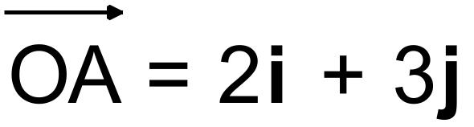, 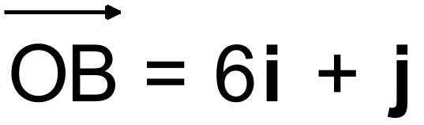 , 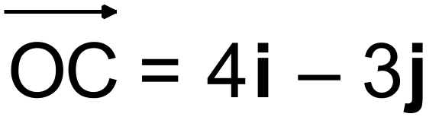 and 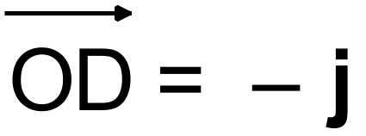.

(a) Determine 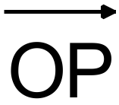 such that AP:PC = 1:1. (2 marks)

(b) A quadrilateral is a parallelogram if its diagonals bisect each other.
Using your answer from (a), show that quadrilateral ABCD is a parallelogram. (3 marks)

(c) A parallelogram is a rhombus if its diagonals are perpendicular.
Determine whether parallelogram ABCD is a rhombus. (2 marks)

Question 9 (5 marks)

The complex number  , with 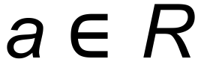 , is such that 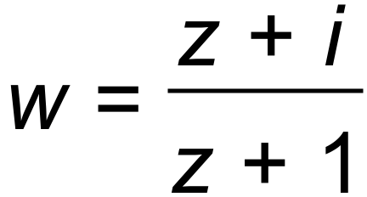 is a real number.
Determine the value(s) of a and hence obtain w. (5 marks)

Question 10 (13 marks)

The diagram below shows semicircle ABC, and the resulting semicircle A’’B’’C’’, after having undergone two matrix transformations, T₁ followed by T₂.

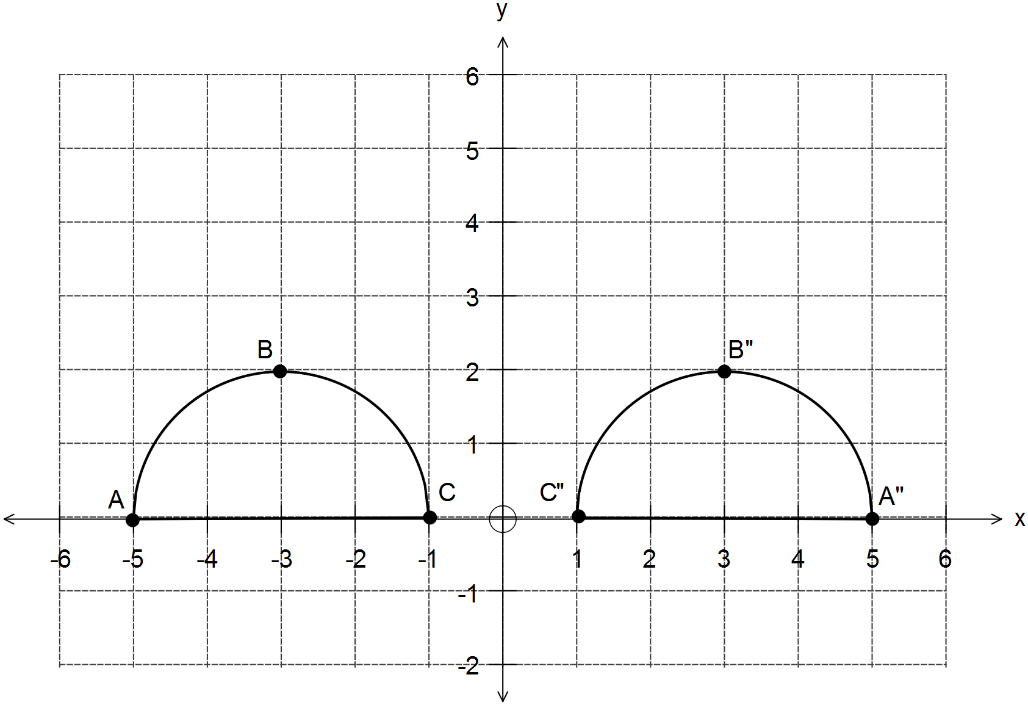

(a) Semicircle ABC is rotated clockwise about the origin by 90° (T₁).
State matrix T₁ and draw the resulting image of semicircle A’B’C’ in the same
set of axes above.
(2 marks)

(b) Semicircle A’B’C’ is then transformed by matrix T₂ to semicircle A’’B’’C’’ as shown.
State matrix T₂ and describe the transformation represented by this matrix.
(3 marks)

Question 10 (Continued)

(c) Show how T₁ and T₂ combine to give a single matrix M that maps the semicircle ABC directly
onto A’’B’’C’’. What single transformation is represented by matrix M?
(3 marks)

(d) The area of semicircle A’’B’’C’’ is the same as the area of semicircle ABC.
How does the matrix found in (c) explain the lack of change in the area? (1 mark)

(e) What matrix would transform semicircle A’’B’’C’’ back to semicircle ABC? (2 marks)

(f) Consider T₃ = 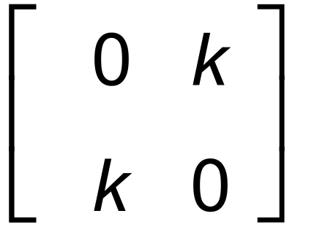. If T₃ is applied to semicircle ABC the area of the resulting semicircle
will be double the area of semicircle ABC. Determine the value(s) of k.
(2 marks)

Question 11 (7 marks)

The diagram below represents a weight that hangs from two fixed strings attached to a ceiling.
The weight exerts a force of 120 N on the system, and this force is then balanced by the two
forces F₁ and F₂ as shown, which act along the strings.
Given that the system is in equilibrium (i.e. the net sum of forces is equal to zero), determine the forces F₁ and F₂ in the format xi + yj, where i and j are the unit vectors in the x and y axis as shown.

Round your answers correct to two (2) decimal places.

W
F₁
F₂
120 N
45°
30°
i
j

(7 marks)

(Deliberately left blank as extra working space for Question 11)

Question 12 (15 marks)

(a) Given that 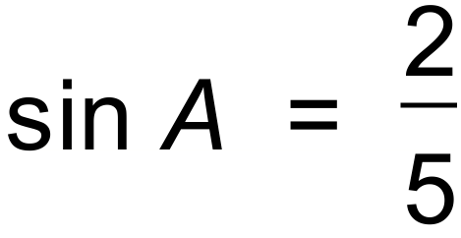 and 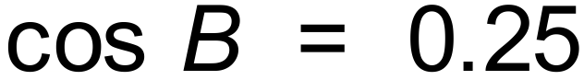, with A and B acute, determine the exact value of:

(i) 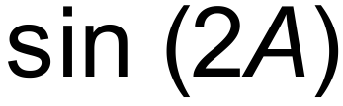. (2 marks)

(ii) 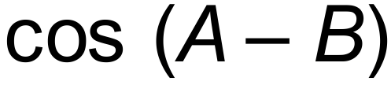. (3 marks)

(iii) 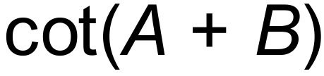. (Rationalise your answer) (3 marks)

Question 12 (Continued)

(b) Use an appropriate product-to-sum identity to show that .

(3 marks)

(c) Use an appropriate product-to-sum identity to show that the equation below has two
solutions in the domain 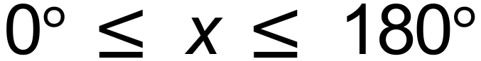. (4 marks)
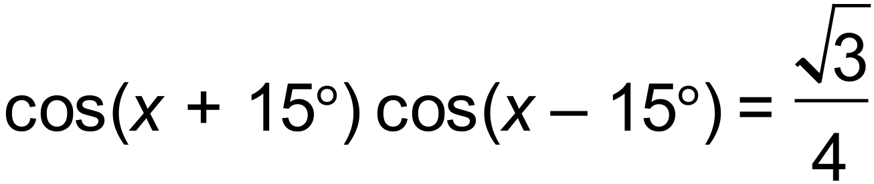

Question 13 (8 marks)

Consider the matrices A, B and C given below:

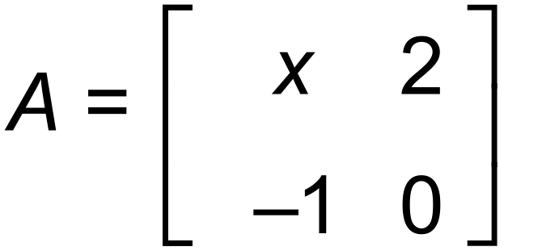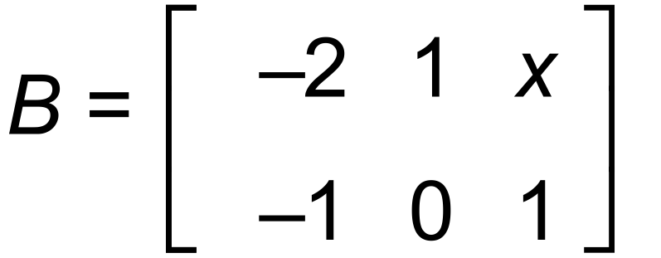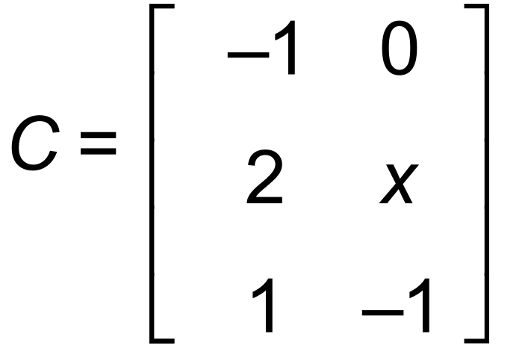

(a) Circle the matrix products listed below that are possible and, if the product is possible then
state the dimensions of the resultant matrix (do not calculate the actual products).
(2 marks)

ABC ACB

BAC BCA

CAB CBA

(b) From any of your answers in (a), calculate a product which resulted in a matrix of size 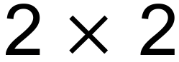.

(2 marks)

(c) Find the determinant of your matrix from (b) in terms of x, and hence, state the value(s)
of x for which this matrix is singular.
(3 marks)

Question 14 (5 marks)

Matrices P, Q and R are all matrices such that 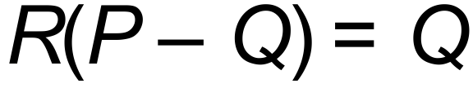.

(a) Show that 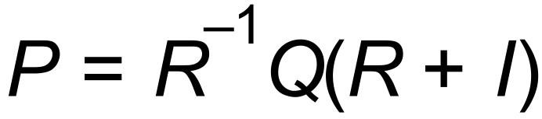 where I is the identity matrix of . (2 marks)

(b) Find P given that 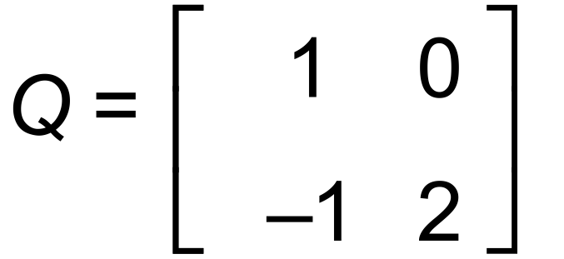 and 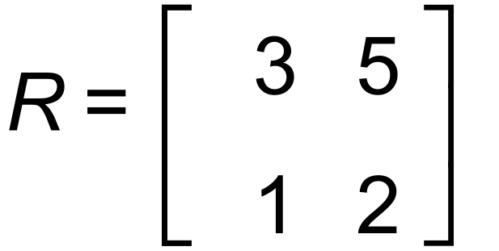. Show working for full marks. (3 marks)

Question 15 (10 marks)

Figure 1 below shows a cylinder of radius 6 cm attached to a spring.
The cylinder is able to move horizontally under the effect of the spring without slipping.

Figure 1
Figure 2
6 cm
5 cm
5 cm

When the spring is compressed by a distance of 5 cm from its point of equilibrium and then released, as shown in Figure 2, the centre of the cylinder moves horizontally such that it returns to its point of equilibrium every 2 seconds. Let x(t) represent the distance of the centre of the cylinder from its point of equilibrium, with x(t) given in cm and t given in seconds.

(a) Sketch the motion of the centre of the circle using the axes provided below. (3 marks)

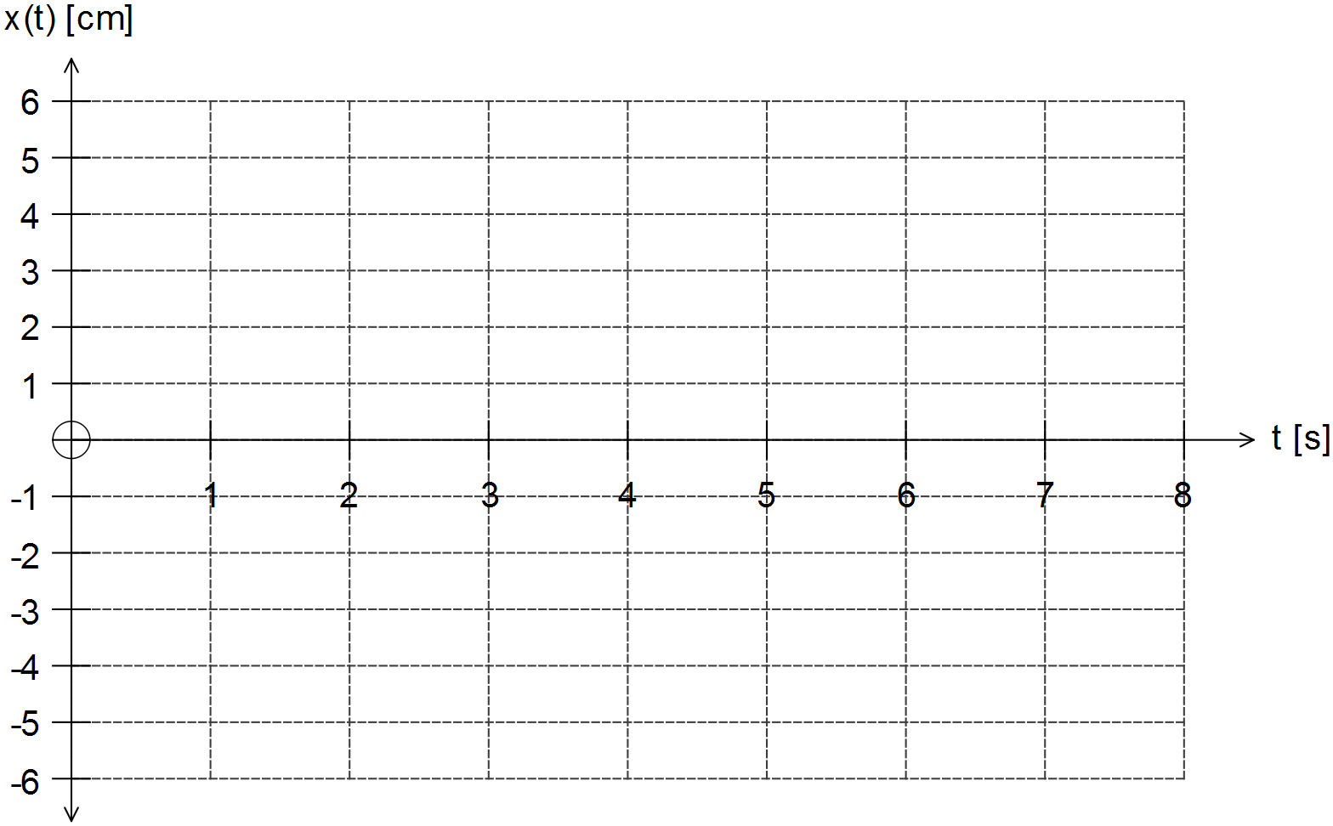

(b) State the equation of motion of the centre of the cylinder 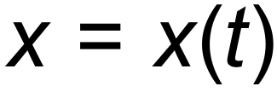, where x is the displacement of the centre from its point of equilibrium at any time t seconds from the spring being released.

(2 marks)

Question 15 (Continued)

(c) How far from the point of equilibrium is the centre of the circle 10.5 seconds from the
spring being released? (1 mark)

(d) At t = 0 the spring is released and the cylinder moves towards the right. How soon after the spring
is released will the centre of the cylinder be 3 cm from its point of equilibrium?
(2 marks)

(e) In another trial, the spring is compressed such that the centre of the cylinder moves according
to the rule 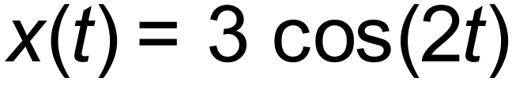. In this case, how many times does the centre of the cylinder pass its point of equilibrium within 10 seconds?
(2 marks)

Question 16 (13 marks)

(a) The Argand diagram below shows the complex numbers z and w.
On the same set of axes sketch  and 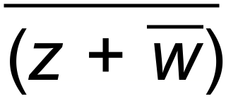. (4 marks)

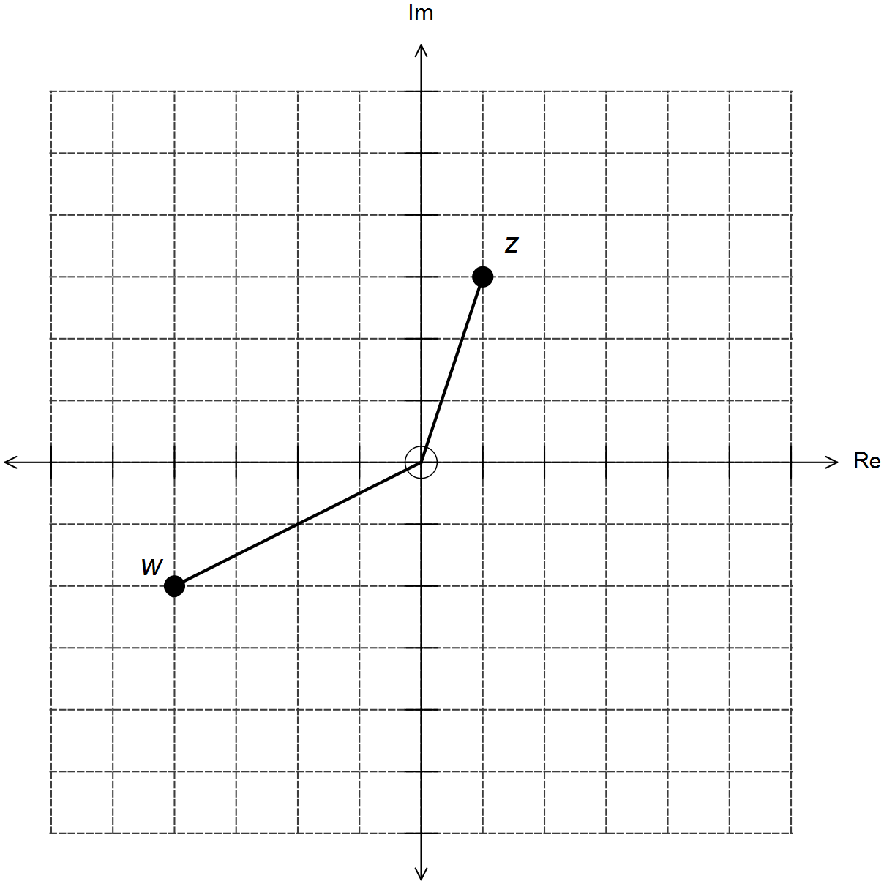

(b) The complex number 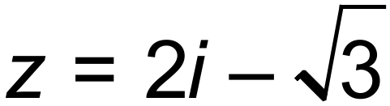 is a solution to the equation 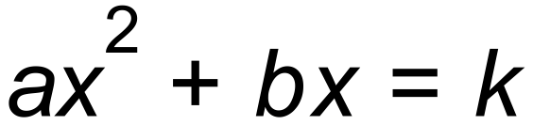, where a, b and k
are real constants. Determine the value(s) of a, b and k.
(4 marks)

Question 16 (Continued)

(c) Consider the complex equation 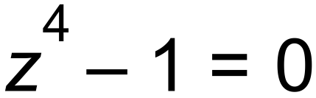.

(i) Fully factorise the expression and hence determine its roots. (3 marks)

(ii) Sketch the solutions found above on the complex plane given below. (2 marks)

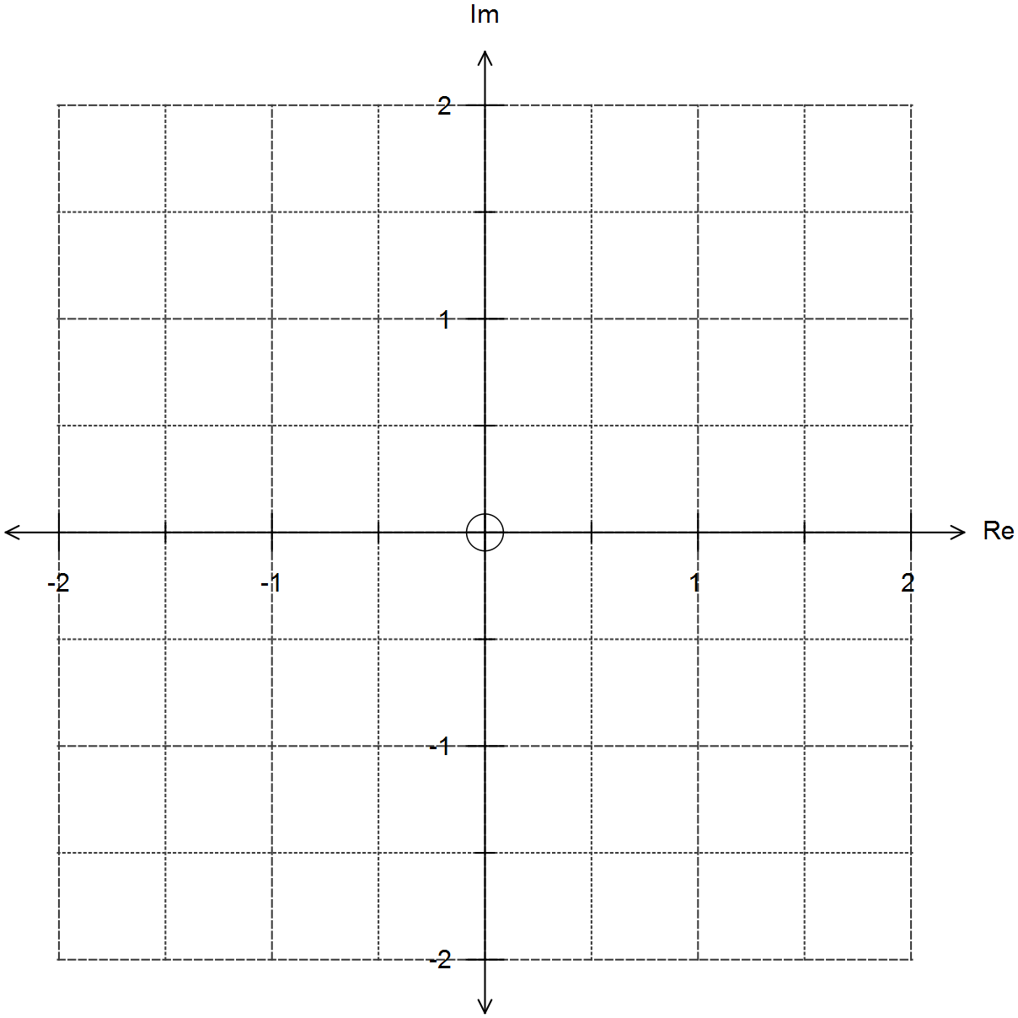

Question 17 (7 marks)

(a) The irrational number 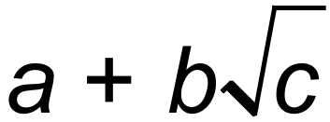 , where a, b and c are integers with 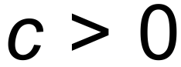 , is defined as the
infinite continued fraction given below. Determine the value(s) of a, b and c.
(4 marks)
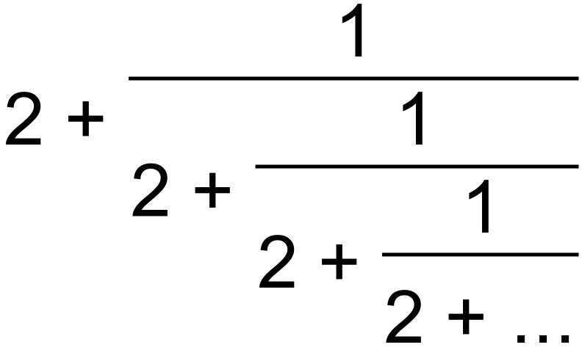 .

(b) Prove that if n is an odd number, then 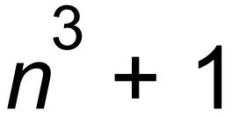 is even. (3 marks)

Question 18 (4 marks)

Prove by contradiction that if 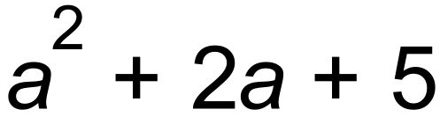 is even, then a is odd 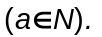
(4 marks)

End of questions
Additional working space

Question number(s): ……………………

Additional working space

Question number(s): ……………………

Additional working space

Question number(s): ……………………

Additional working space

Question number(s): ……………………

Additional working space

Question number(s): ……………………

